Quantum Approach

The final equation that we want to solve is:

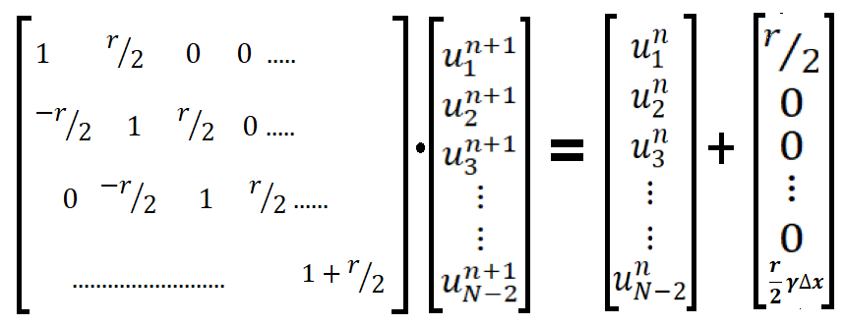

**A**   **x b**

Considering a smaller dimension (4x4) of matrix A. It can be broken down in the following manner:

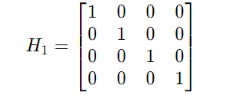

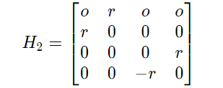

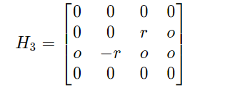

Note: r/2 has been replaced by r for clarity

This set of Hi matrices can be realized in a quantum circuit using the following unitary gates:

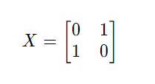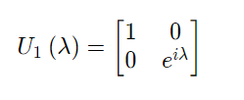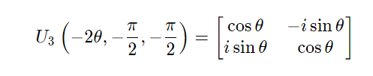

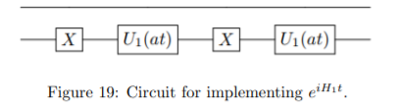



HHere a = 1

U3(-2r, -pi/2, -pi/2)

Circuit for implementing eiH2t



Circuit for implementing eiH3t

For a general n ∈ N and A ∈ C 2nb×2nb , the circuits for H1 and H2 do not change since they correspond, respectively, to

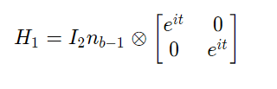 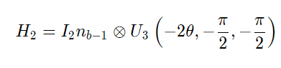

H3 can be extended using the following blocks

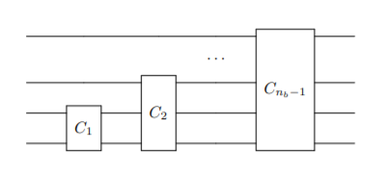

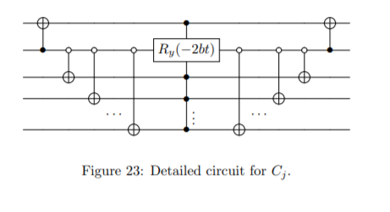

Here Ry(-2bt) = U3(-2θ, -pi/2, -pi/2)

Now our original matrix A can be approximated as 

We will keep m=1 to keep calculations simple

Now this circuit corresponds to Quantum Phase estimation in the HHL algorithm for finding solution to system of linear equations. After integrating this with Initialization circuit and Eigenvalue inversion, we can solve our original equation Ax = b to calculate the wave at any given timestep.

Reference:

http://www.sam.math.ethz.ch/~hiptmair/StudentProjects/CarreraVazquez.Almudena/MScThesis.pdf